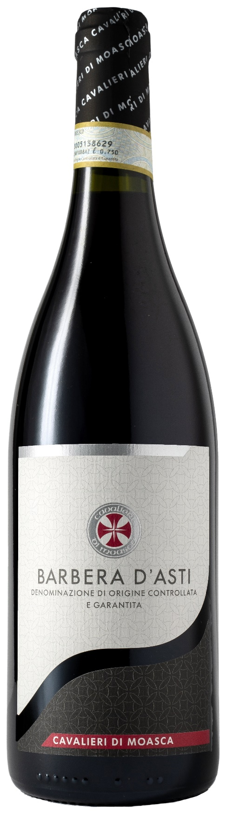
BARBERA D’ASTI DOCG – CAVALIERI DI MOASCA

Grape: Barbera 100%
Alc. Vol.%: 13,5
Vintage: 2024
Residual sugar g/l: 5,4
Total acidity g/l: 5,7
Region: Piedmont
Production zone: Vineyards in the area of Moasca and Agliano Terme (Asti)
Capacity: 750ml, 1500ml

CHARACTERISTICS

Vinification: At a controlled temperature. The peel maceration takes 12 days in steel tanks
Aging: 8 months in steel tanks
Yield per ha: 9000kg
Colour: Deep intensive red
Bouquet: Fruity, winy and essential
Flavour: Dry, full-bodied with pleasantly integrated tannins

SERVING SUGGESTIONS

Best enjoyed with spicy starters and meat courses.
Serving temperature 18 °C
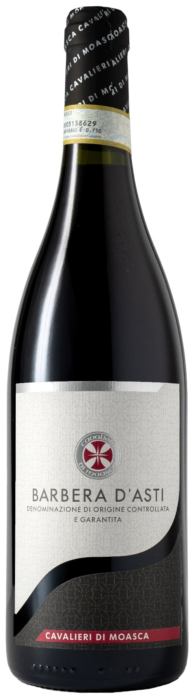
TECHNICAL INFORMATION / PALLETIZING

Size 750ml:
Article Nr. V06003A
GTIN-13 bottle 8017868003007
GTIN-13 carton 8017868002161
Closure Cork
Bottles / carton 6 bottles
Pallet size 80x120cm
Cartons/layer 24
Cartons/pallet 120
Kg/carton 7,8
Kg/pallet 958

Size 1500ml:
Article Nr. V06002B
GTIN-13 bottle 8017868003014
GTIN-13 carton 8017868002222
Closure Screwcap
Bottles / carton 6 bottles
Pallet size 80x120cm
Cartons/layer 14
Cartons/pallet 56
Kg/carton 13,08
Kg/pallet 960

Contains sulphites
GMO Free
Revisione 01. 21.04.2026

